Structure

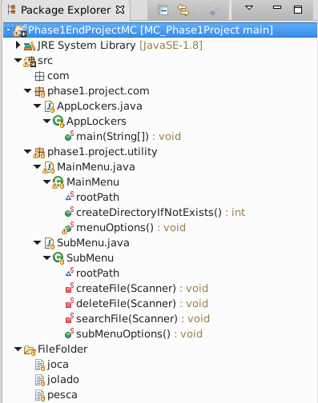

Run Applockers.java, then option1, then “y” to continue, then option 3 to exit
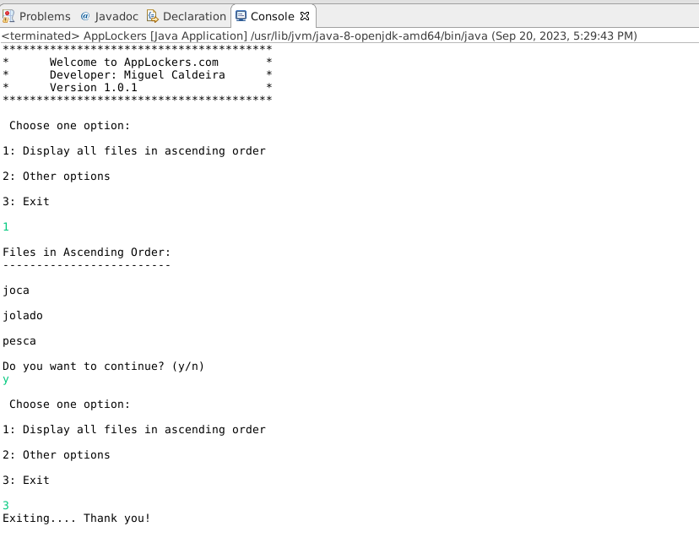

Same as before, but whan asked if I want to continue, chose “n”

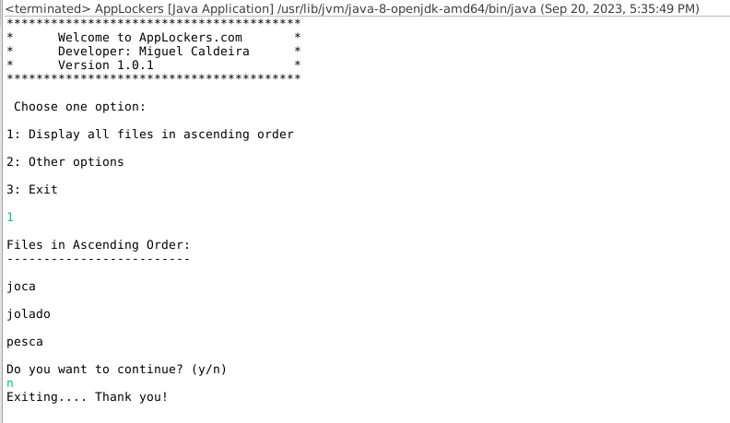

This time chose option 2 in main menu, then option 1 to create fil, return to previous menu and check file creation
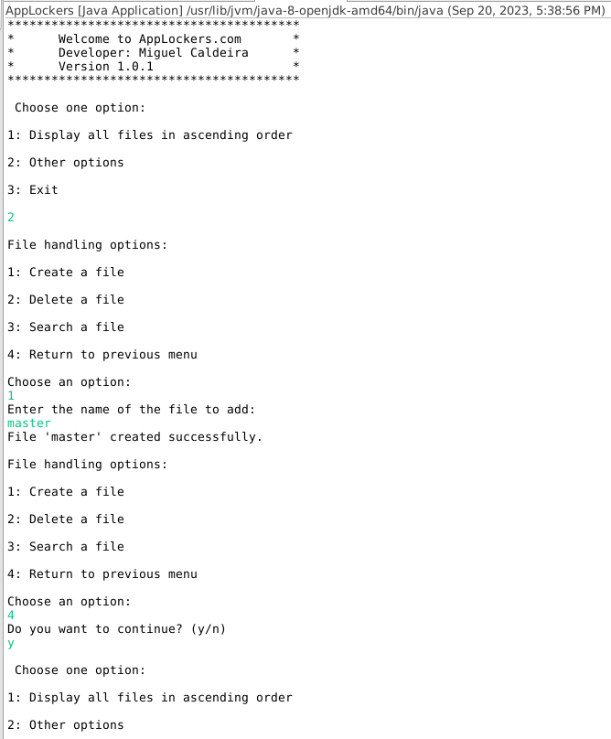

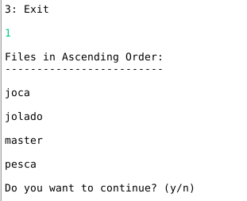

Option 2 in submenu to delete. Tried to delete file but with wrong case, program returns message and continues, then successfully delete file with correct case, then confirm is deleted

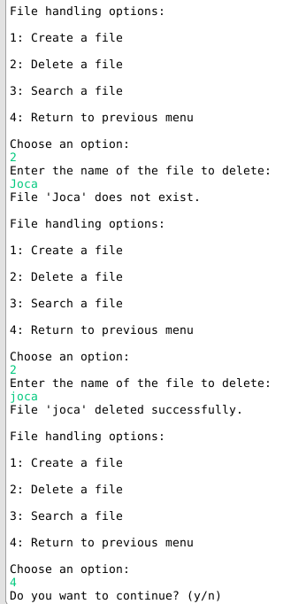
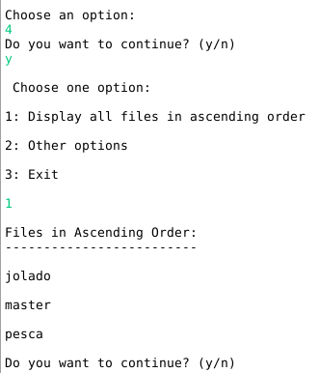
check file doesn’t exists using search option
